**Users Documentation**

## Search Patient

* User can search patient by patient Id and perform the functions like Update patient, View Patient EMR and View EMR Report.
* If patient do not exists user will get Dialogue box will pop up to inform that requested patient does not exist
* if patient exists in the System, Users can perform Various functions from this User Interface.
* User can get the appointment list of a specific doctor

## Update Patient Demography

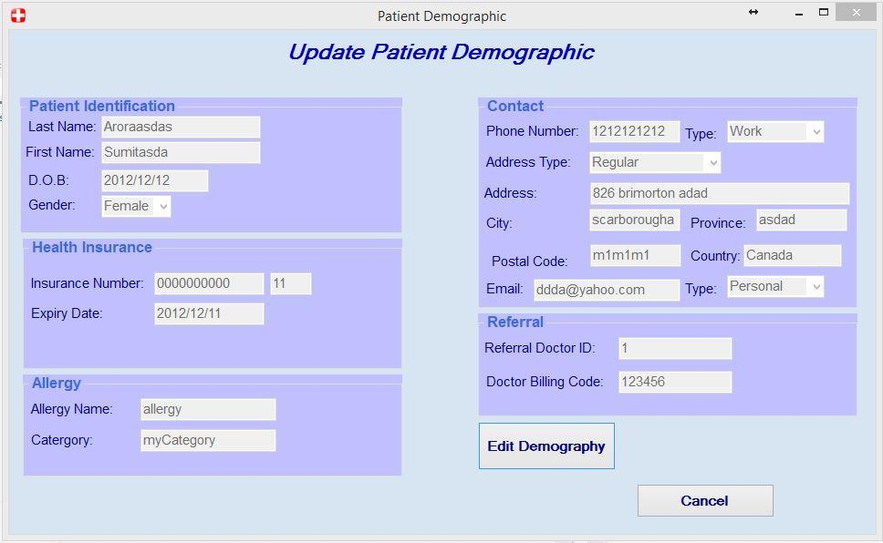

* On clicking Update patient button user will get this User Interface which shows all the patient demography information.
* On clicking Edit Demography button user will see the below image

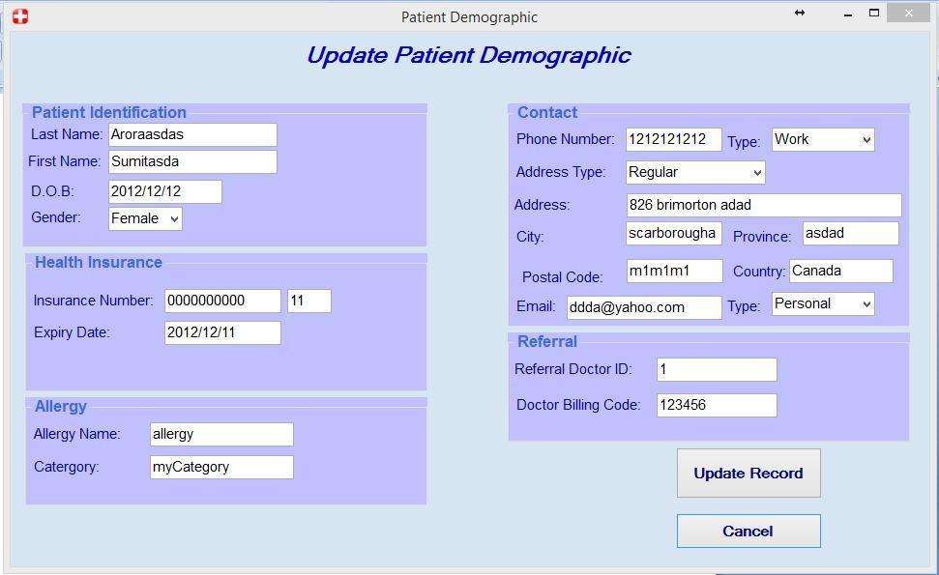

* Users can update the patient Information and click Update Button to Update it to the system.
* Users can press cancel button to close this User Interface screen.

## View Patient EMR

Users can see Patient Information on the top of the User Interface Screen.

### View Patient Radiology

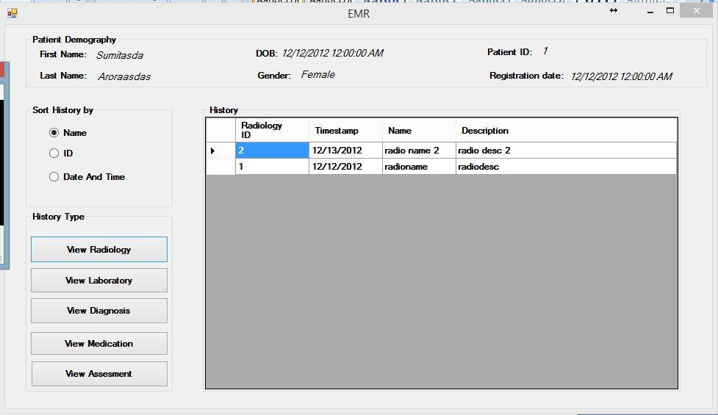

* By clicking View Radiology button, Users can see Radiology order history of the patient and can sort them according to Name , ID or Order Date and Time.
* The history details include Radiology ID, Time Stamp, Name and Description of that particular Radiology order.

### View Patient Laboratory

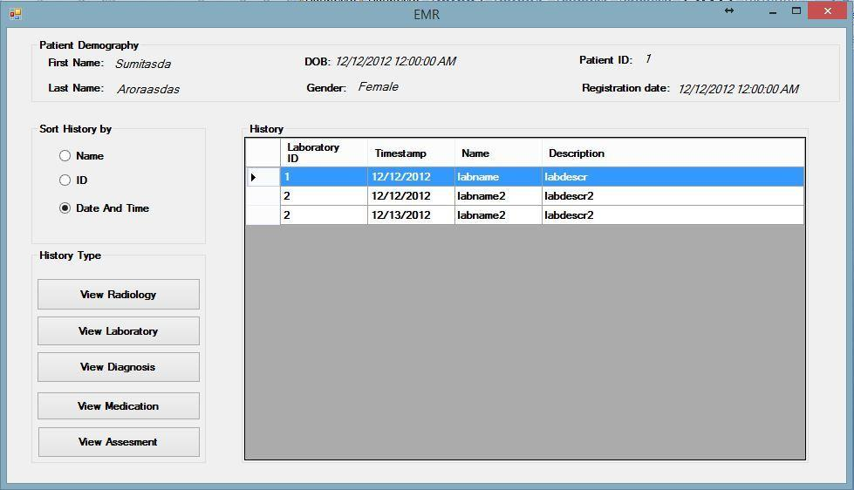

* By clicking View Laboratory button, Users can see Laboratory order history of the patient and can sort them according to Name , ID or Order Date and Time.
* The history details include Laboratory ID, Time Stamp, Name and Description of that particular Laboratory order.

### View Diagnosis

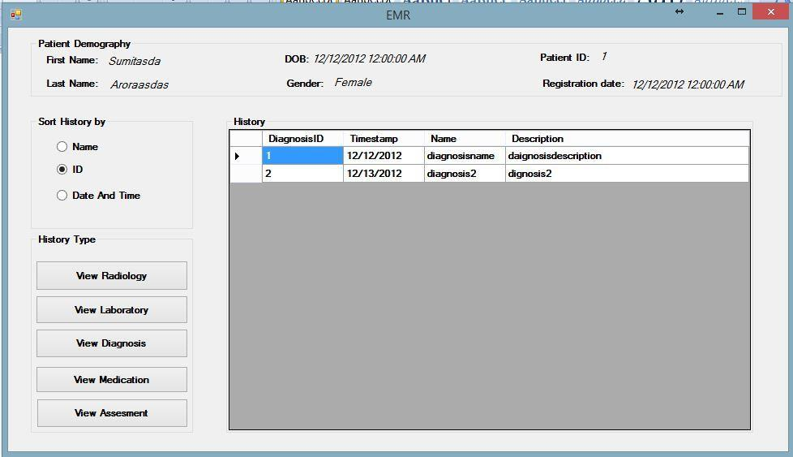

* By clicking View Diagnosis button, Users can see Diagnosis order history of the patient and can sort them according to Name , ID or Order Date and Time.
* The history details include Diagnosis ID, Time Stamp, Name and Description of that particular Diagnosis order.

### View Medication

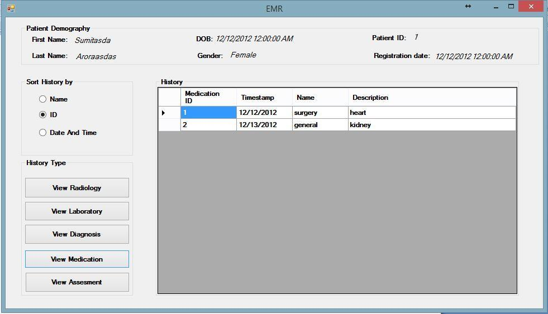

* By clicking View Medication button, Users can see Medication order history of the patient and can sort them according to Name , ID or Order Date and Time.
* The history details include Medication ID, Time Stamp, Name and Description of that particular Medication order.

## View Patient Assessment

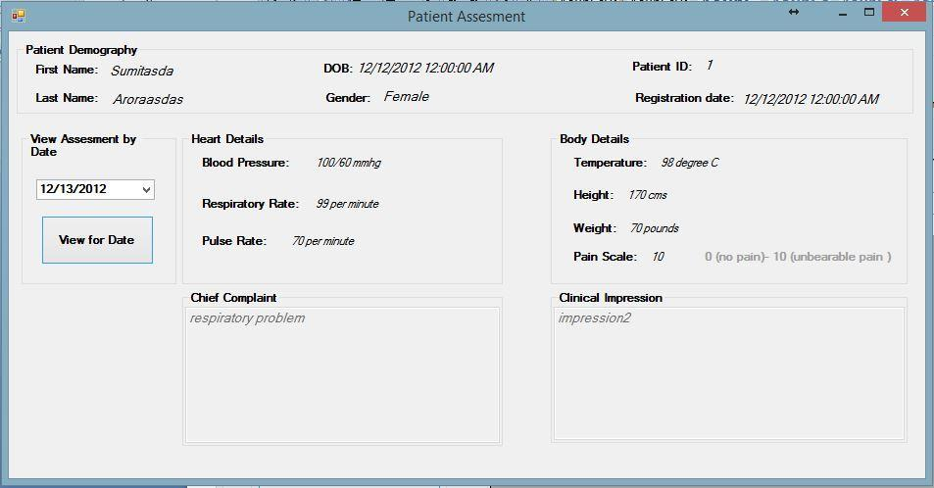

* Users can see Patient Information on the top of the User Interface Screen like Name, Dob, Patient Id, Gender and Registration Date.
* Users can select assessment for particular date selecting date from the drop down list and click view for Date to view assessment for selected date.

## View or Print Patient EMR Report

### 

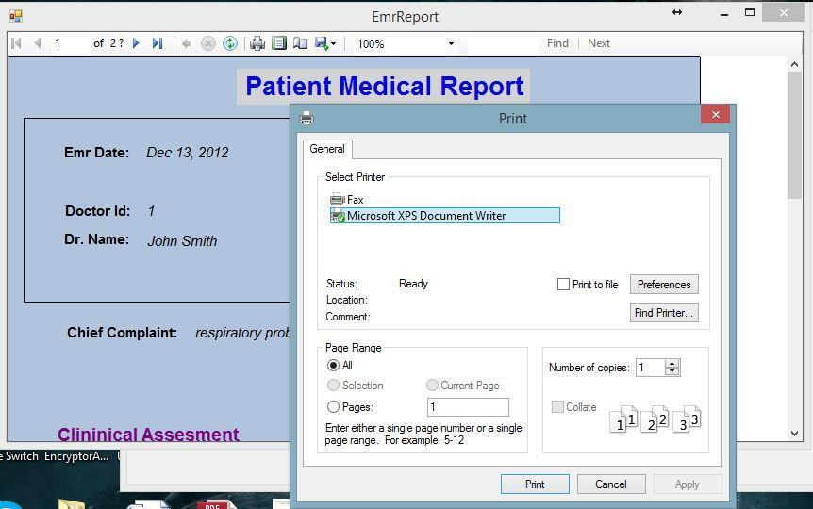

* Users can View Patient Medical Report.
* Users can perform zoom in and zoom out functions on the report.
* Users can go to Next page or enter page number to go to that page number.
* Users can refresh report.
* Users can find word or sentence in the report.
* Users can export the report to various format like pdf, word or excel format.
* Users can set up print page layout and print report.

## View or Print Daily Patient Treated Report

### Select Date from drop down calendar for which user want to generate Daily

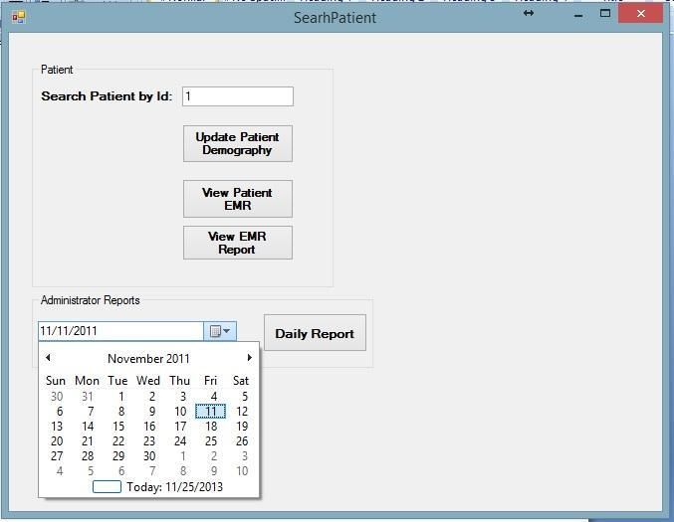

### View and Print Daily Report

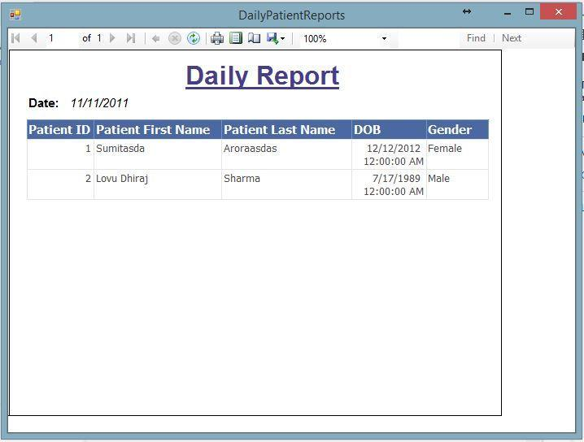

* Users can see Information of patients treated on particular date. The information like Patient Id , First Name, Last Name , Dob, Gender can be seen for individual patient seen by doctor.
* Users can View Daily Report.
* Users can perform zoom in and zoom out functions on the report.
* Users can go to Next page or enter page number to go to that page number.
* Users can refresh report.
* Users can find word or sentence in the report.
* Users can export the report to various format like pdf, word or excel format.
* Users can set up print page layout and print report.

## 7. View patient demographic

* From the Search Patient window, if the patient is already registered, user can view his/her demographic
* This view contains sufficient information to identify a patient (by Patient OHIP number)
* User can have an overview of the patient through this window: name, age, contact, etc
* There are some functional buttons located on the right side of the window:
  + User can print Patient Lab by using DYMO Label printer, for example and attach to a lab requisition or referral letter

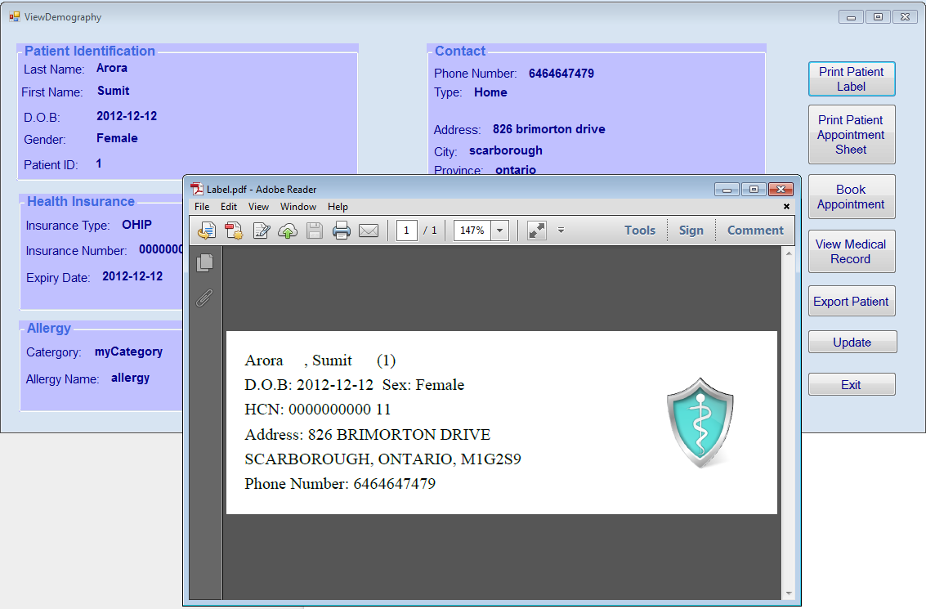

* + User can print Appointment Sheet. In some clinics, physicians are still using paper chart so they will use this paper to take note when seeing patient. Or it can be used by specialists who want to take notes and dictate after seeing patient.

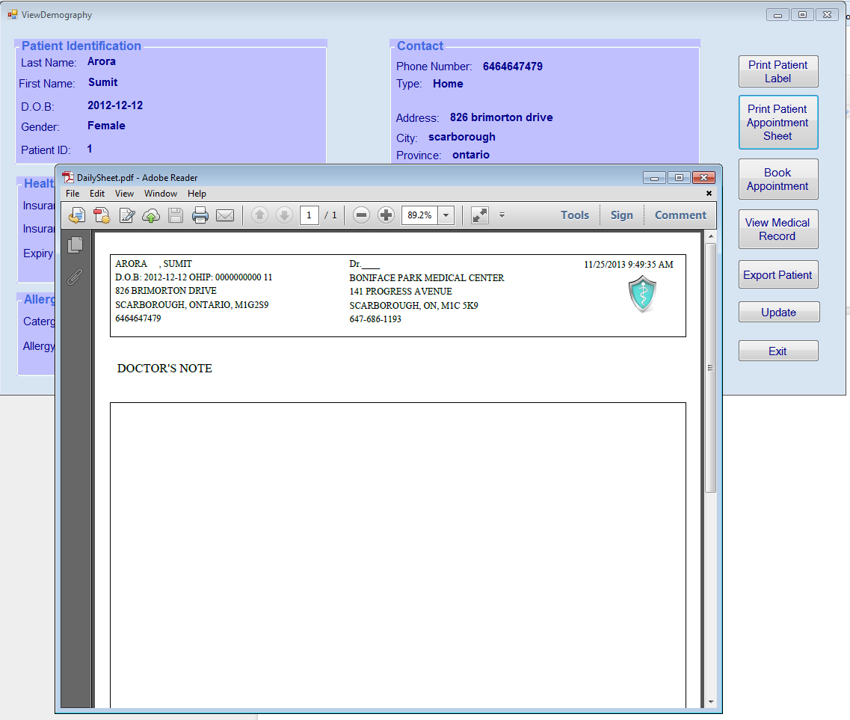

* + When a patient checks in at front desk, user is able to add patient to a list of the doctor he/she has an appointment today. Note: the drop down list only shows name of the doctor has schedule on that day. If there is no doctor working on that day, the list will be blank.

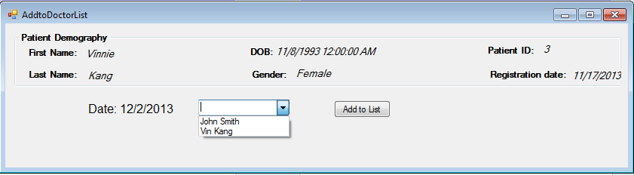

## 8. Register Patient

In the search patient window, if patient hasn’t been registered yet, there will be a dialog pop-up and ask if user would like to register patient (create new demographic)

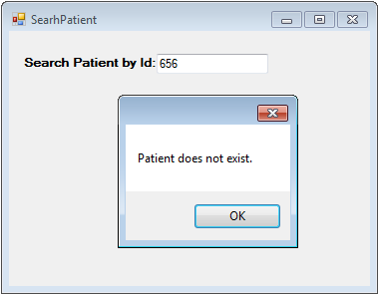

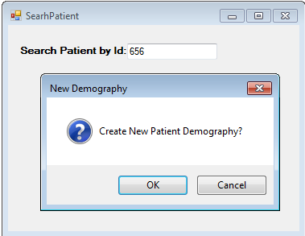

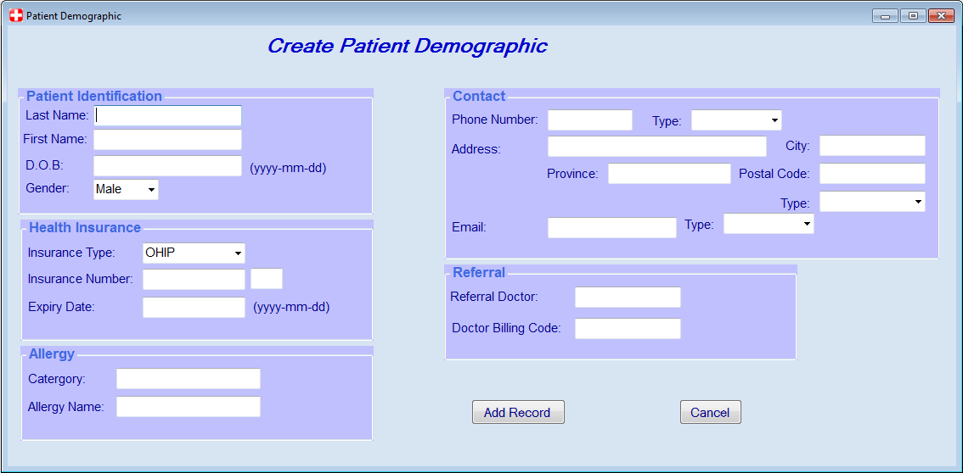

* In this form Patient Identification and Health Insurance are mandatory. There are some validations to minimize human errors.
* Date of Birth and OHIP Expiry Date are using format yyyy-mm-dd
* OHIP contains 10 digits and 2 letters
* Allergy, Contact and Referral are optional
* After user adds records, a dialog will pop-up and ask if user would like to see View Demography form of the patient just created.

**User story :Search Patient**

Search whether the patient exits or not ,if exists then go to the patient’s record and if the patient does not exists then create a new demography .

To search a patient you need to select an item from a combobox named Search By Name and Patient ID

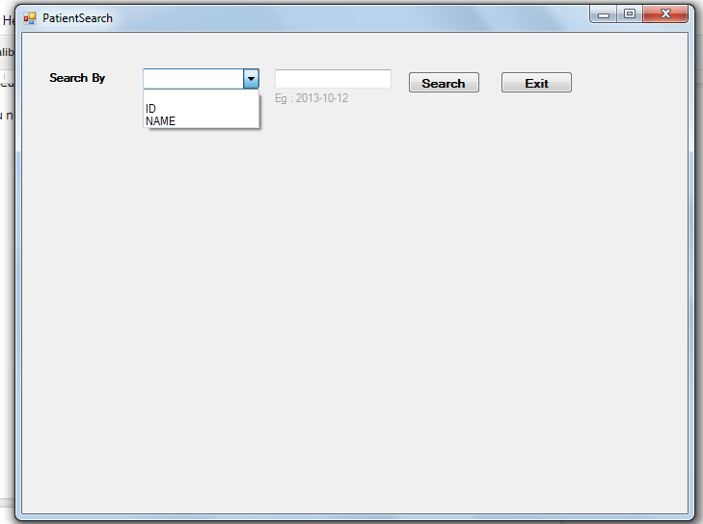

You can Search by ID as typing in the textbox any numerical value

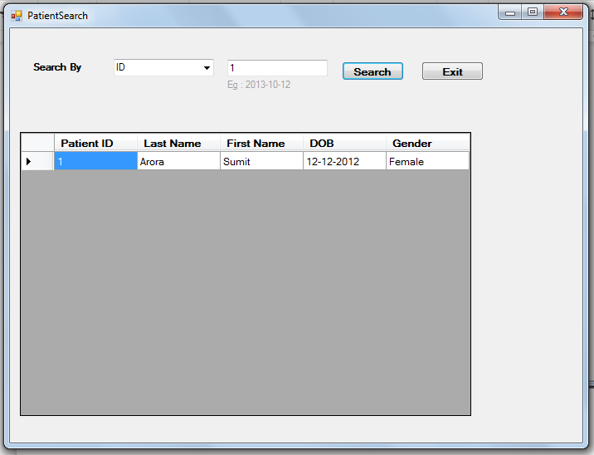

You can also search a patient with its Name by typing alphabets

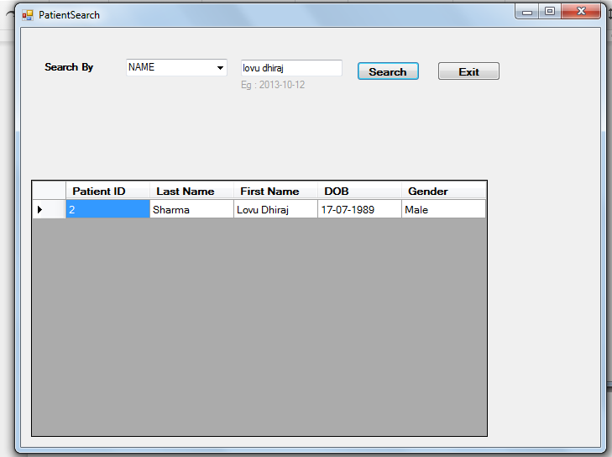

if the patient does not exist then,you click on the empty box then you will be leaded to the next form where you can create new Patient Demographic.

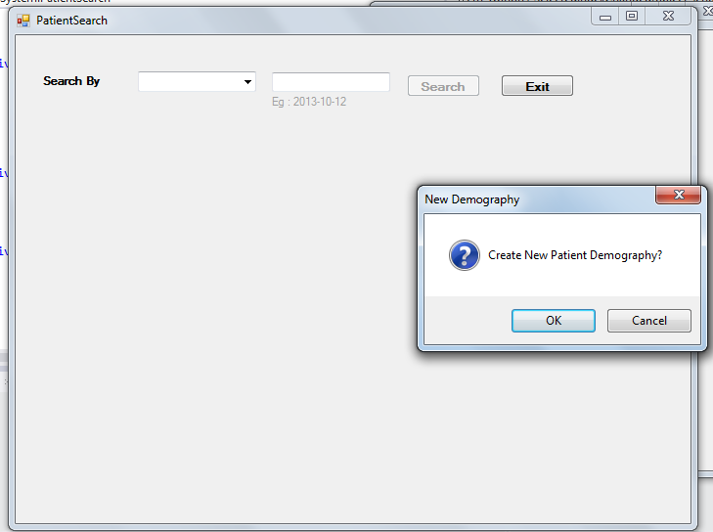

**User Story : Enter Patient Assessment**

**To enter patients assessment**

**You can enter Patients**

**· Blood Pressure**

**· Respiratory Rate**

**· Pulse Rate**

**· Temperature**

**· Height**

**· Weight**

**· Pain Scale**

**· Chief Complaint**

**· Clinical Impression**

**And then click on Save button to save the entered text .**

